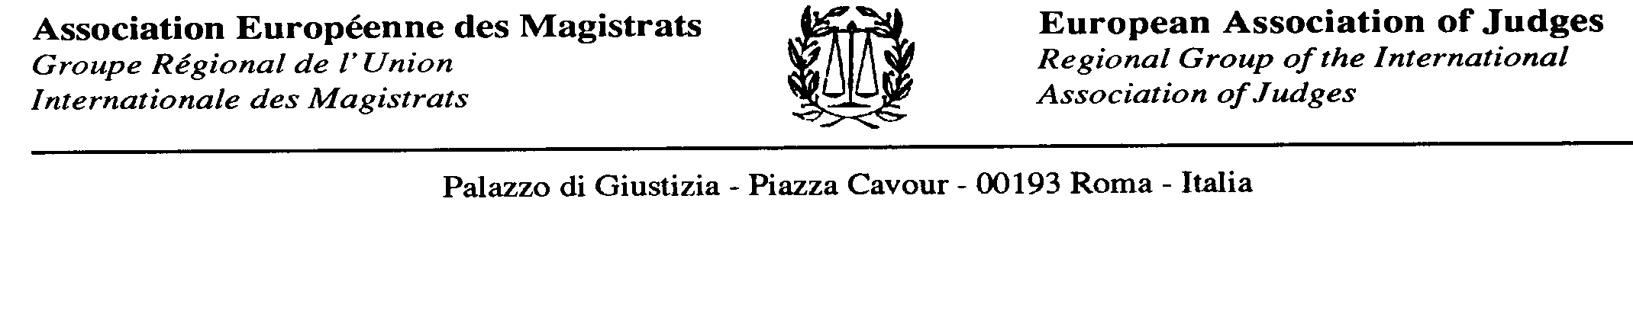

18 February 2019

Mr. Frans Timmermans
Vice - President of the European Commission

Dear Mr Timmermans,

The European Association of Judges is deeply concerned with the situation in Poland.

Therefore, allow us to underline the unacceptable pressure on the Polish judiciary caused by undue disciplinary procedures initiated against the national judges.

In this sense we adhere to the "rationale" and conclusions of the attached letter sent by Polish Judges Association IUSTITIA to Your Excellency.

We ask you to use all your possibilities and also those of European Commission to urge the Polish authorities to stop this clear violation of Rule of Law and also of its essential prerequisite: an independent judiciary.

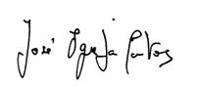

José Igreja Matos
President of the European Association of Judges

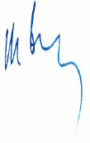
Mikael Sjoberg
Vice President of the European Association of Judges

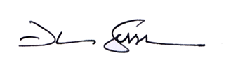
Duro Sessa
Vice President of the European Association of Judges

